EE 210

HW#: 01

Last Name: **Aldacher**

First Name: **Muhammad**

ID: **011510317**

Date: **9/1/2020**

Assigned question #s: 3

1. **Collect 10 to 20 seconds of your voice with and plot it using Matlab, Octave, or any other programs.**

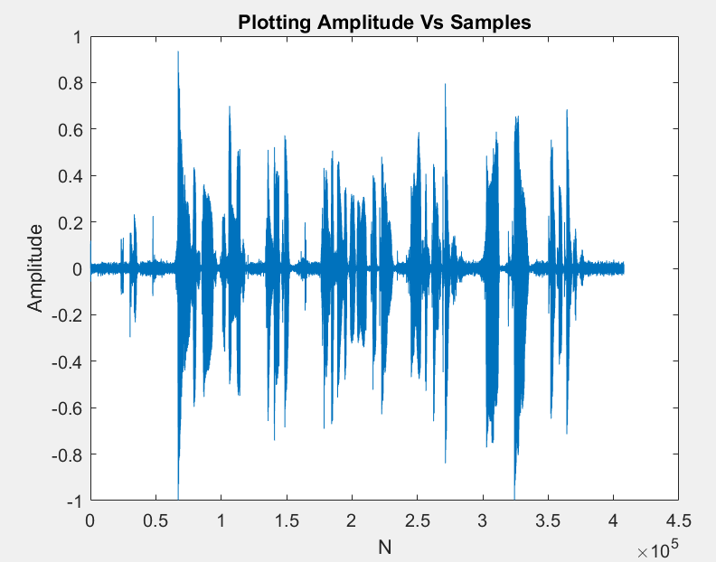

Matlab code:

[x,fs] = audioread('Muhammad_Aldacher_ee210.wav');

plot(x)

sound(x,fs)

title('Plotting Amplitude Vs Samples')

xlabel('N'); ylabel('Amplitude')

1. **Change frequency (f) from 100~20kHz in the program. And find how much of frequencies you can hear.**

* I can hear up to 16000 Hz (16 KHz).

Matlab code:

A = 0.5;

fs = 44100;

n = 0:2*fs-1;

f = 16000;

x = A*cos(2*pi*f*n/fs);

sound(x,fs)

plot(n,x)

1. **Plot frequency response (magnitude response) of your voice and write observations that where(range of frequencies) most of energies are stored at**

* Most of the energies is concentrated in the frequency range of 100 Hz to 2000 Hz.

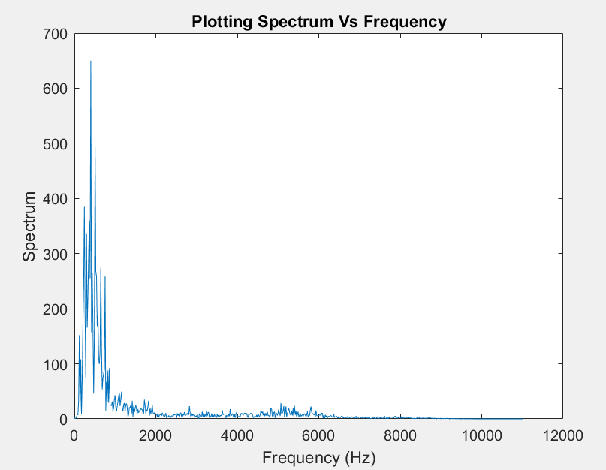

Matlab code:

[x,fs] = audioread('Muhammad_Aldacher_ee210.wav');

N = length(x);

n = 0:N-1;

OM = 0:0.005:pi;

X = exp(-j*OM'*n)*x;

fq = OM*fs/(2*pi);

figure

plot(fq,abs(X))

title('Plotting Spectrum Vs Frequency')

xlabel('Frequency (Hz)'); ylabel('Spectrum')